In this lab I will be uploading an example zip file to a splunk server and querying it for information. Beginning the lab, I connected to splunk uploading the data into the “test” index for easier searching.

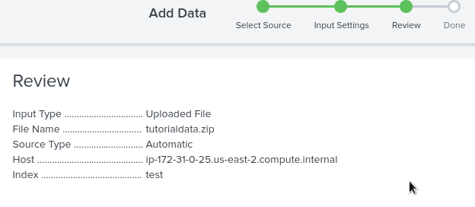

How many different client IPs are there requesting the "/productscreen.html" path?

Using the GUI more fields option “url_path”, I am able to make a table of the amount each path was used. The path "/productscreen.html" was used 82 times.

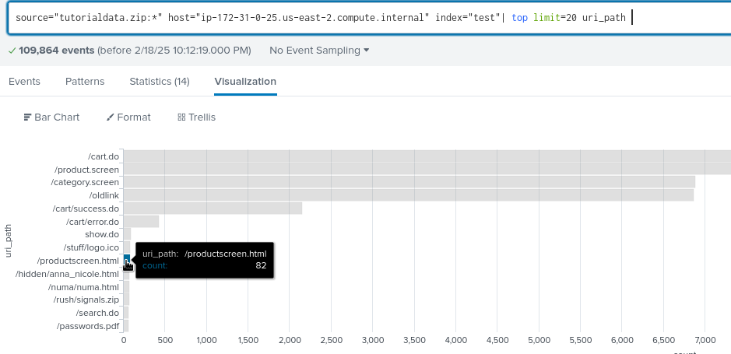

What is the path where the client IP address "128.241.220.82" sends the most web requests?

Adding the search variable clientip=”128.241.220.82” narrows the graph to only show requests made by this IP. The result of this search shows that /cart.do was 128.241.220.82 most requested search with 198 requests.

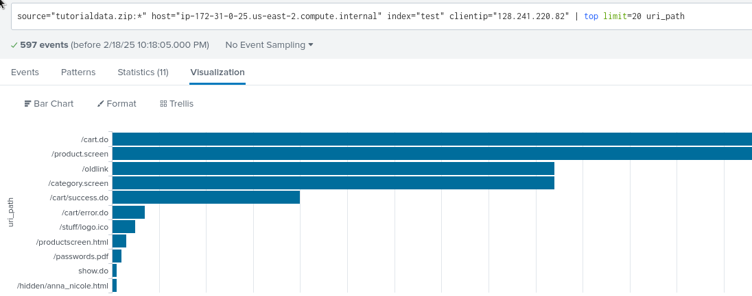

To check or add a user to this splunk you can go to Settings -> Users And Authentication, clicking on the User tab will show that our splunk has only the admin user. Clicking on the Roles tab shows that our splunk contains five roles.